**P250/1**

**GEOGRAPHY**

**(Physical Geography)**

**Paper 1**

**Jul/Aug 2016**

**3 Hours**



**MUKONO EXAMINATIONS COUNCIL**

**Uganda Advanced Certificate of Education**

**GEOGRAPHY**

Physical Geography

Paper 1

**Time: 3 Hours**

**INSTRUCTIONS TO CANDIDATES**

* *This paper consists of* ***three*** *sections* ***A****,* ***B*** *and* ***C****.*
* *Answer* ***four*** *questions.*
* *Section* ***A*** *is compulsory.*
* *Answer* ***one*** *question from section* ***B*** *and* ***one*** *question from section* ***C.***
* *Credit will be given for use of relevant diagrams and specific examples studied in the field.*
* *Any additional question(s) answered will not be marked.*

**SECTION A**

*Question* ***1*** *and* ***2*** *are compulsory*

**COMPULSORY MAP WORK QUESTION**

1. Study the map extract East Africa 1:50000 (UGANDA) MPARA series Y732, Sheet 67/2 Edition 1-USD and answer the questions that follow.
2. Giving evidence from the map extract;
3. determine the hemisphere in which Mpara is located. ***(02marks)***
4. describe the location of Mpara. ***(02marks)***
5. Calculate the D’Tour index of the Dry weather road. ***(02marks)***
6. (i) Draw a Transverse along Northing 52 between Eastings 69 and 77 and on it, mark and name;

* two relief features
* one drainage feature
* two vegetation types
* out crop rock
* any one landuse type. ***(11marks)***

(ii) Calculate the Horizontal equivalent of your transverse. ***(02marks)***

1. Explain the relationship between drainage and vegetation. ***(06marks)***
2. 2. Study the photograph provided and answer the questions that follow.

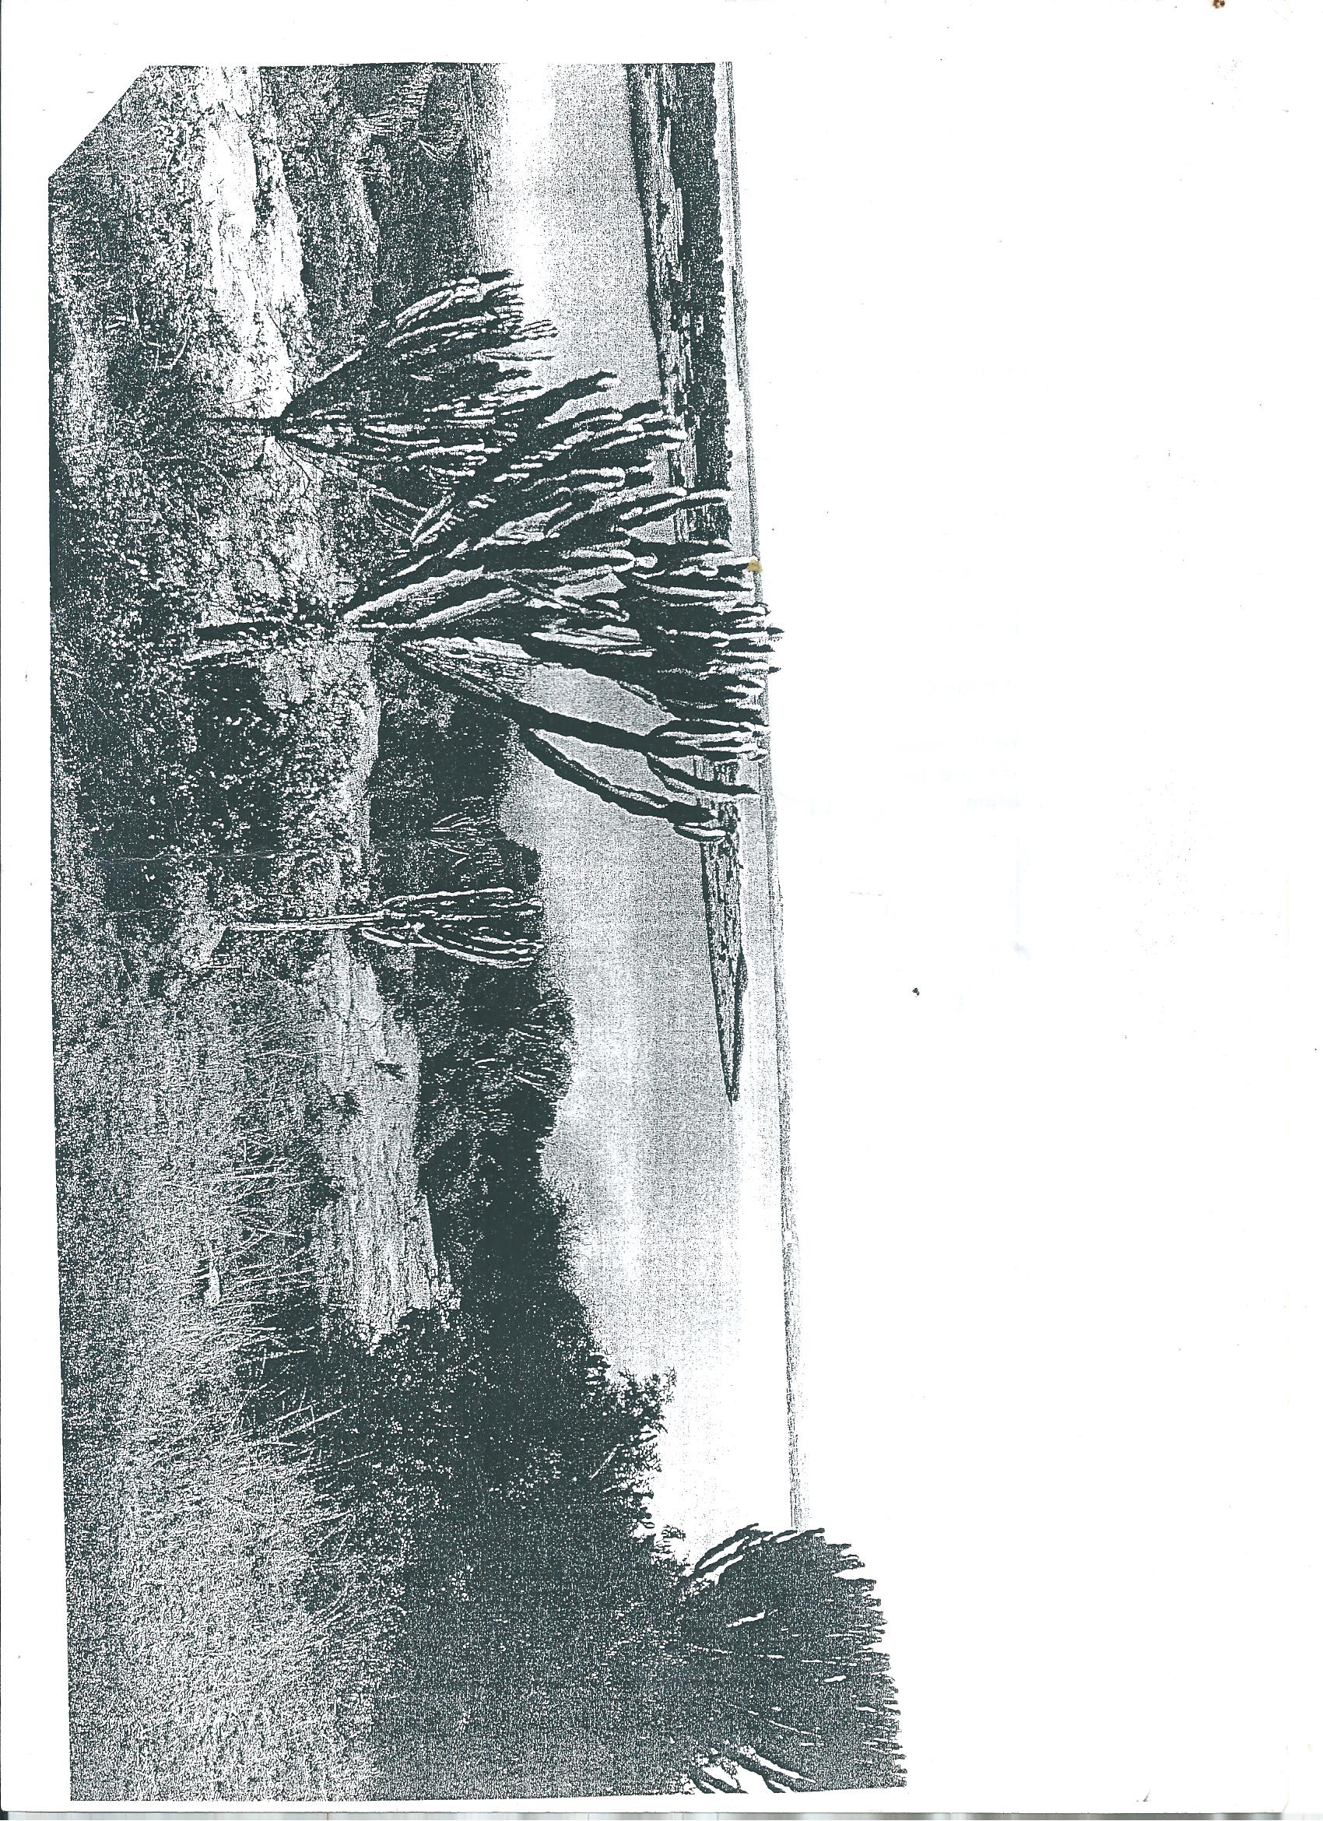

1. Draw a landscape sketch of the area covered by the photograph and on it, mark and label;
2. 3 major physiographic features.
3. 2 vegetation types
4. 2 drainage features
5. Bare ground ***(11marks)***
6. (i) Describe the characteristics of the vegetation type shown in the photograph.

***(04marks)***

(ii) Account for the growth of the vegetation type in (b)(i) above.

***(04marks)***

1. Account for the formation of any two physiographic features identified in (a) above.

***(04marks)***

1. Giving reasons for your answer, identify one are in East Africa where the photograph could have been taken from. ***(02marks)***

**SECTION B**

*Attempt* ***one*** *question from this section.*

1. a) Account for the formation of metamorphic rocks. ***(15marks)***

b) Assess the importance of metamorphic rocks in East Africa. ***(10marks)***

1. Examine the processes responsible for the formation of a pyramid peak. ***(25marks)***
2. a) Distinguish between submergence of coastlines and emergence of coastlines.

***(10marks)***

b) Account for the formation of landforms resulting from submergence of coastlines on

a highland coast.

**SECTION C**

*Attempt* ***one*** *question from this section*

1. a) Distinguish between tropical cyclones and temperate cyclones. ***(12marks)***

b) Examine the effects of cyclones on the climate of the areas where they occur.

***(13marks)***

1. To what extent have human factors modified savannah vegetation in East Africa?

***(25marks)***

1. Explain the processes that influence soil profile development. ***(25marks)***

***End -***